Prescription Advantage
P
Prescription
Advantage
Your Plan for Affordable Prescriptions
Program Information and Application Instructions

What is Prescription Advantage? Prescription Advantage is a state-sponsored prescription drug program administered by the
Commonwealth of Massachusetts Executive Office of
Elder Affairs for seniors and people with disabilities.

Who is eligible?
Prescription Advantage is available to Massachusetts residents who are:

- Age 65 or older, eligible for Medicare, and have a gross annual household income less than 500% of the Federal Poverty Level, or
- 65 years of age or older and not eligible for Medicare, or
- Under age 65, work no more than 40 hours per month, earn no more than the maximum income to qualify for category 2 or S2 and meet MassHealth’s CommonHealth disability guidelines.
- Not MassHealth or CommonHealth members in plans offering Prescription coverage*

*Individuals with comprehensive MassHealth programs or MassHealth Buy-In programs, also known as Medicare Savings Programs (MSP) are not eligible for Prescription Advantage.

Additional information:

- The enclosed Prescription Advantage Rate Schedule Guide provides specific benefit information by membership category for Medicare and non-Medicare eligible members.
- There is no premium for Prescription Advantage coverage. In certain circumstances, a yearly enrollment fee may apply (see the Prescription Advantage Rate Schedule Guide).
- Individuals eligible for Medicare must also be enrolled in a Medicare prescription drug plan or a plan offering creditable coverage.**
- Prescription Advantage members are entitled to a one-time Special Election Period (SEP) each year that allows members to join or switch their Medicare drug plan outside of Medicare’s open enrollment period.
- Prescription Advantage members and those applying to Prescription Advantage may be eligible for additional State and Federal programs that can help lower costs even further. Please review pg. 3, Section E of this document for more information.

**Creditable coverage is coverage as good or better than drug coverage offered by Medicare and is usually provided by an employer or union.
Important Message
Applicants eligible for Medicare may apply for Prescription Advantage if they are not yet enrolled in a Medicare prescription drug plan. However, applicants must be enrolled in a Medicare or creditable coverage prescription drug plan before they can receive any benefits from Prescription Advantage.

The Prescription Advantage application is available in other languages upon request.
Interpretation assistance for non-English speakers is available.
Administered by the Commonwealth of Massachusetts Executive Office of Elder Affairs Revised January 1, 2022

Massachusetts Residents Eligible for Medicare

Prescription Advantage provides secondary coverage to help pay for prescription drugs covered by a primary Medicare Part D or creditable coverage plan. Refer to the Prescription Advantage Rate Schedule Guide for specific benefit information based on membership category.

Once co-payment assistance begins, members pay no more than the co-payment amounts listed on the
Prescription Advantage Rate Schedule Guide for their membership category. If the total spending for
co-payments reaches the out-of-pocket spending limit, Prescription Advantage will cover the co-payments for covered drugs for the remainder of the calendar year.

Note: Out-of-pocket spending costs begin to accumulate once a person becomes a Prescription Advantage member. Any costs incurred prior to the effective date of coverage cannot be applied towards the out-of-pocket spending limit.

Massachusetts Residents Not Eligible for Medicare

Prescription Advantage may be able to offer primary prescription drug coverage to those not eligible for Medicare.

All non-Medicare members must pay co-payments until an annual out-of-pocket spending limit is reached. Depending on membership category, non-Medicare members may be required to pay a quarterly deductible as well.

Once members reach the out-of-pocket spending limit, Prescription Advantage pays the full cost of the members’ covered drugs through the end of the calendar year. See the Prescription Advantage Rate Schedule Guide for specific benefit information.

You may apply for Prescription Advantage online, by phone, or by mail.

To apply online, go to www.prescriptionadvantagema.org

To apply by phone, call 1-800-243-4636

To apply by mail, send the completed application and copies of your required documentation to:

Prescription Advantage
P.O. Box 15153
Worcester, MA 01615-0153 or fax to 508-793-1133
For questions or assistance with this application, call Prescription Advantage Customer Service at:

1-800-243-4636; TTY (toll free) at 1-877-610-0241
for the deaf and hard of hearing with Text Telephone capability.

Representatives are available to help you Monday - Friday, 9:00 am - 5:00 pm EST.

The Prescription Advantage application is available in other languages upon request.
Interpretation assistance for non-English speakers is available.

Prescription Advantage Application Instructions
P
Prescription
Advantage

Thank you for your interest in Prescription Advantage, the state-sponsored prescription drug program administered by the Commonwealth of Massachusetts Executive Office of Elder Affairs. This booklet provides detailed instructions for completing the Prescription Advantage Application Form. If you have any questions, please call Prescription Advantage Customer Service at 1-800-243-4636 or TTY (toll free) at 1-877-610-0241 for the deaf and hard of hearing with Text Telephone capability.
Representatives are available to help you Monday - Friday, 9:00 am - 5:00 pm.

General Information

  - This application may be used for you alone, or for you and your spouse, if you live together and both wish to apply. Any other member(s) of your household applying for Prescription Advantage must complete a separate application.

  - Carefully read and answer all questions. Please print except where a signature is indicated.

  - The Prescription Advantage Rate Schedule Guide included with the application provides important Prescription Advantage benefits information. Review the guide and keep it nearby for reference as you complete the form.

  - Prescription Advantage uses gross annual household income to determine the appropriate membership category. Common types of income include Social Security, employment, pensions, annuities, dividends/interest, retirement account(s) disbursements, capital gains, unemployment, rental, and alimony. You must verify any income you receive. The Income Documentation section on page 5 of this booklet lists acceptable documents to verify your income.

  - Make copies of all the documents, such as federal tax returns and/or 1099 forms, you must send to
Prescription Advantage. Original documents cannot be returned to you.

  - You may authorize someone to have access to your Protected Health Information by completing an Authorization Form. Representatives may be designated at any time. If you wish to name a designee, carefully review the Representative Authorization Forms enclosed with this application to determine which type of designee is best for you. Complete the appropriate form(s) and submit it with your application.

  - To apply by mail, sign the completed application form and mail it with your documentation to:

Prescription Advantage
P.O. Box 15153 Worcester, MA 01615-0153

or fax to 508-793-1133

• To apply by phone, call 1-800-243-4636; TTY at 1-877-610-0241.

    - To apply online, go to www.prescriptionadvantagema.org

Section A: Applicant and Spouse Information (page 1)
This section asks questions about you. If someone is completing this application on your behalf, please include the person’s name and his/her relationship to you. If you and your spouse live together, you must complete all the Spouse sections of the application even if he/she is not applying for benefits.

Section B: Residence and Contact Information (page 1)
Prescription Advantage is only available to those with a primary residence in Massachusetts. A primary residence is one in which you reside for at least six (6) months during the calendar year. You may not give a post office box as a primary residential address. A seasonal or temporary residence in Massachusetts does not qualify as a primary residence.

If you sometimes reside at another location (e.g., you leave the state for the winter), you must notify customer service before you leave for that location so we can update your mailing address in case we need to contact you. You must also notify customer service when you return to your primary address.
- Cell phones are not considered to be a secure means of transmitting personal information. For your protection, we suggest that you do not provide a cell phone number. If the only way to contact you is by cell phone, be aware that any personal information discussed may not be secure.

Section C: Household Information (page 2)
This section asks questions about any relatives, other than your spouse, that live in your household and depend on you for at least one-half of their financial support. The number of relatives living in your household may affect the benefits you receive. If there are more than two people (other than you or your spouse) in your household, call Prescription Advantage for more information regarding income eligibility requirements.

Section D: Other Prescription Drug Coverage (page 2)
Indicate any health coverage you and/or your spouse have that covers prescription drugs. You are responsible for comparing your current drug coverage with the coverage provided by Prescription Advantage to determine if you need Prescription Advantage supplemental coverage.

If you are eligible for Medicare, you may apply for Prescription Advantage if you are not enrolled in a Medicare prescription drug plan. However, you must be enrolled in a Medicare or creditable coverage drug plan before you can receive any benefits from Prescription Advantage.

Section E: Extra Help From Medicare and MassHealth Buy-In Program also known as Medicare Savings Program (page 2)
If you are a Medicare beneficiary with limited income and resources, you may qualify for the low income subsidy from Medicare, known as ‘Extra Help’. Extra Help may lower your deductible and co-payments and help pay your monthly Medicare prescription drug plan premium. Prescription Advantage requires all members who may qualify for this program to apply for this benefit.

If you are a Medicare beneficiary with limited income and resources, you may qualify for the MassHealth Buy-In program, also known as Medicare Savings Program (MSP). MSP may lower your deductible, co-payments, coinsurance, and help pay your monthly Medicare premiums. Prescription Advantage requires all members who may qualify for this program to apply for this benefit.

Be sure to answer the questions in this section to help us determine if you may qualify for Extra Help and / or the MassHealth Buy-In (MSP) program. After reviewing your application, we will let you know if you might be eligible and we will assist you with this process. NOTE: Eligibility for Extra Help has no effect on eligibility for Prescription Advantage. However, eligibility in the MassHealth Buy-In (MSP) program impacts your eligibility with Prescription Advantage.

Section F: Employment and Disability for Applicants Under 65 Years of Age (page 3)
This section provides employment and disability status information for you and your spouse. If you are under
age 65 and do not have a qualified disability, you are not eligible for Prescription Advantage.

Section G: Income Information (page 3)
Please be sure to answer the questions regarding Social Security income and federal income taxes in Section G. A list of acceptable income documentation can be found in the Income Documentation on page 5 of this booklet.

Important Notes About Income Calculation:
- You must verify any income you receive. A list of acceptable income documents is provided on page 5.
If there is income you receive that is not listed, please call customer service for acceptable documentation.

- Income is calculated using the total income as reported on federal income tax returns. ALL applicants who file federal tax returns must submit a copy of their most recently filed return.

- For applicants not required to file a federal income tax return, income is calculated using alternative documents.

- Income counted includes the total amount of money, earned or unearned, from any source, including but
not limited to Social Security, wages, business income, rents, pensions/annuities, dividends, and interest.

- Income is calculated using your gross annual household income. This is the amount prior to any deductions you may have for healthcare costs or other purposes.

- In some cases, income listed on your federal tax return that you no longer receive will not be used to calculate income. You must verify that you do not receive the income or cannot receive it again. This applies to wages, business income, IRAs, pensions/annuities, third-party sick pay, unemployment, and alimony. Documents that may be required for removal of income are listed on page 5 of this instruction booklet.

Signatures (page 4)
Carefully read the statements in this section and sign and date the bottom of the page. Because we require information regarding your household income, your spouse should also sign if he/she lives with you, even if he/she is not applying at this time. We cannot process your application without the appropriate signatures.

Authorized Designees
There are three types of representatives with different levels of authorization – an Authorized Representative, a Release of Information Designee, or a Temporary Authorized Representative. Included with this application is a Representative Authorization Form with detailed descriptions and forms for each type of representative.
Use this form if you wish to appoint a representative. The authorization form cannot be processed unless signed
by all persons listed on the form.

Additional Information
- Your application is not complete until we receive all required documentation. If any information is missing, you will receive a yellow letter listing the information and/or documentation you still need to provide. When all information is received, your application will be evaluated. If you are eligible, you will be approved for the program.
- It is your responsibility to keep Prescription Advantage updated if your information changes. Failure to do
so may result in denial of your application or the termination of your membership.

Income Documentation

You must send the income documents listed below that apply to you. All documents must be for the PREVIOUS calendar year. For example, in 2022, the documents must be for 2021.
If you FILE federal income taxes, send copies of:
  - Your most recently filed federal income tax return 1040, 1040A, or 1040EZ. State tax returns will not
be accepted.
If you DO NOT FILE federal income taxes, you may need to send copies of:
- Your current Social Security benefit award letter or Cost of Living Adjustment letter listing the amount you receive before deductions or your Social Security annual benefit statement (SSA-1099 form)
  - Your most recent 1099 or W-2 form(s) for each type of income listed below that you receive. If you do not receive 1099 or W-2 form(s), contact customer service for other documents you may submit.

Pensions/Annuities | Railroad Benefit Income | Rental Income
Dividends/Interest | Employment Income | Capital Gains
Retirement (IRA; 401K; 403B) | Unemployment | Alimony

In some cases, we may be able to deduct income listed on your federal tax return that you no longer receive when we calculate your income. You may need to send documentation to prove that you do not receive the income. The types of removable income and documents you must send are listed below.

Income Type | Documents Required for Removal of Income
Wages  (send items 1 and 2) | - Letter from former employer on company letterhead indicating last day worked and  - W-2(s) showing total amount earned from that employer to verify total on tax return.
Third-Party Sick Pay (send item 1) and (send item 2 or 3) | - Letter from institution that paid the disability stating the benefit is exhausted and  - W-2(s) with the total amount paid through disability to verify total on tax return; or  3. 1099 forms for all third-party sick pay received by the applicant/member.
IRA  (send items 1 and 2) | - Document from company that administered IRA indicating account is closed and  - 1099 forms for all IRA accounts in the applicant/member’s name.
Pensions/Annuities (send items 1 and 2) | - 1099 forms for all pensions/annuities received by applicant/member and  - Document from company that administered pension/annuity stating the account is closed.
Unemployment (send items 1 and 2) | - Document from Department of Workforce Development, Division of Career Services and Division of Unemployment Assistance or the Department of Employment and Training stating applicant/member exhausted his/her funds and  - 1099-G showing total unemployment received as noted on Form 1040 (line 19).  NOTE: If an applicant’s/member’s spouse also received unemployment and exhausted his/her funds, the same documents for the spouse must also be provided.
Alimony  (send item 1 or 2) | - Copy of divorce decree outlining details of alimony including end/ended date or  - Letter from provider of alimony payments indicating the date the payments ended.

Application Checklist
Check off each box as you read the statement below to ensure this application is complete and ready for processing. Missing information will delay your application.

Did you remember to:

- Include the following documentation?

  - Proof of income for all members of your household;

  - Proof of disability if you are under age 65;

  - A copy of your insurance card for any coverage you may have, including Medicare Part D;

  - If your prescription drug coverage comes from an organization that is not a Medicare Part D plan: A copy of a letter from the administrator of your prescription drug coverage indicating that you have creditable coverage;

  - If required, a copy of any letter received from Social Security regarding your application for Extra Help;

  - A copy of the front of your Medicare card (if you have Medicare);

- Provide your spouse’s information and signature if you live together, even if your spouse is not applying at this time?

- Send copies of all of your documentation? (Originals will not be returned.)

- Complete, sign, and include the Representative Authorization Form if you wish to designate a representative(s)? This form cannot be processed unless signed.

- Sign and date the application?

- Make a copy of the application and all enclosed documentation for your records?

- Apply the appropriate postage? Insufficient postage may delay or prevent the receipt of the application.

If you have any questions or need assistance completing this application, please call Prescription Advantage Customer Service at 1-800-243-4636, or TTY (toll free) at 1-877-610-0241 for the deaf and hard of hearing with Text Telephone capability. Representatives are available to help you Monday - Friday, 9:00 am - 5:00 pm EST.

Prescription Advantage • P.O. Box 15153 • Worcester, MA 01615-0153

www.prescriptionadvantagema.org

P
Prescription
Advantage
P.O. Box 15153 Worcester, MA 01615-0153
1-800-243-4636 www.prescriptionadvantagema.org
TTY 1-877-610-0241 (toll free) for the deaf and hard of hearing

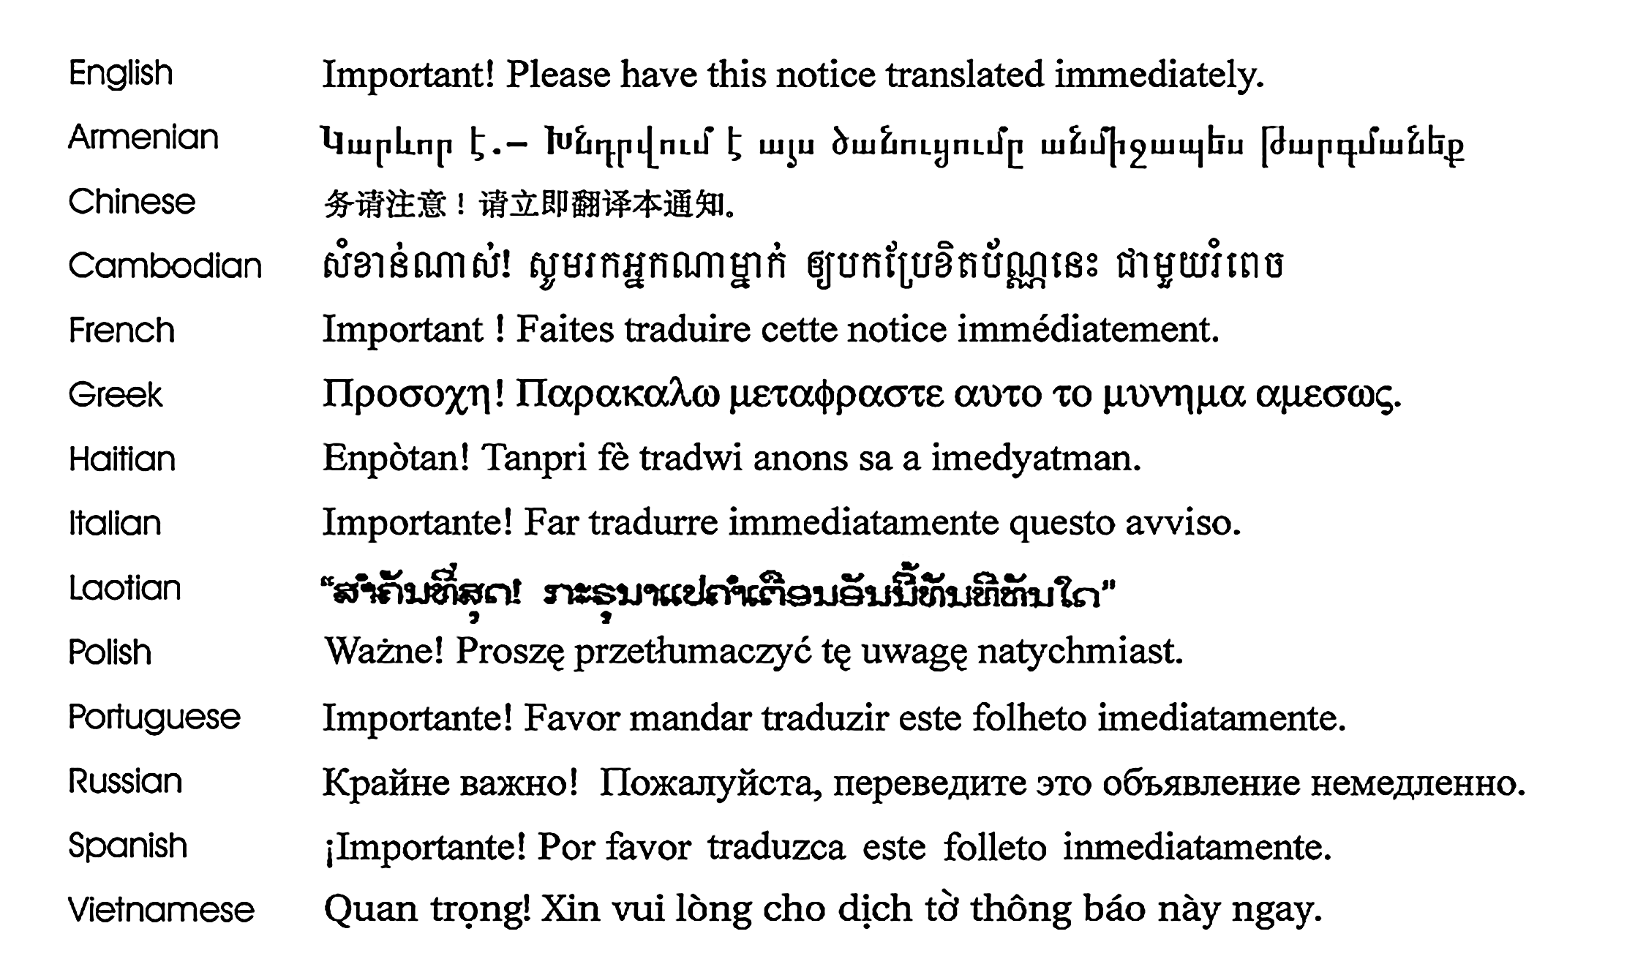
Revised January 1, 2020

